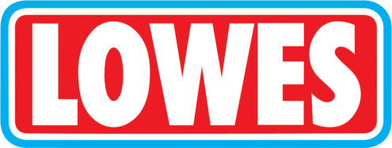


UNIFORM PRICE LIST
MONDAY 8.30 AM TO 10.30 AM and WEDNESDAY 2.00 PM TO 4.00 PM
www.lowes.com.au

STUDENT NAME: _________________________________________________ GRADE: ____________________

DATE: __________________ MOBILE: __________________________ REASON: __________________________

 | Item | Colour | Sizes | Cost | Size | Qty | Total
47668 | Short Sleeve Polo | Navy/Jade | K2-K16, A16-A18 | $32.00
50990 | Long Sleeve Polo | Navy/Jade | K2-K16, A16-A18 | $35.00
51325 | Windcheater | Ink Navy | K4 – K16 | $26.00
47667 | Grade 6 Polo | White | K8-K16, A14-A20 | $35.00
96923 | Grade 6 Bomber Jacket | Ink Navy | K8-K16, A14-A20 | $47.00
47671 | Grade 6 Sport Top | Navy | K8-K16, A14-A20 | $50.00
89256 | Zip Front Jacket | Navy/Jade | K3 – K16 | $55.00
77596 | Summer Dress | 8302 | K3 – K16 | $47.00
77634 | Pinafore | 9044 | K4 – K16 | $55.00
56616 | Skivvy | Jade | K4 – K12 | $15.00
73490 | Double Knee T/Pant | Ink Navy | K4 – K16 | $22.00
50587 | Straight Leg Pant | Mid Navy | K4 – K16 | $24.00
54954 | Lycra Skort | Navy | K4 – K16 | $25.00
92911 | Rugby Short | Navy | K4 – K16 | $20.00
99792 | Puffer Jacket | Navy | K4 – K16 | $65.00
89097 | School Bag | Navy | One Size | $55.00
98060 | Book Folio with Strap | Navy | One Size | $17.00
98677 | Slouch Hat | Navy | 55/57/59/61 | $12.00
98649 | Legionnaire Cap | Navy | One Size | $ 8.00
98639 | Bucket Hat | Navy | 55/57/59/61 | $10.00
99069 | Art Smock | Navy | XS-S-M | $20.00
71229 | Polar Fleece Scarf | Navy | One Size | $10.00
99201 | Knit Beanie | Navy | One Size | $ 6.00
99210 | Ribbed Beanie | Navy | One Size | $ 7.00
77808D | Headband with bow | 8302 | One Size | $10.50
77808J | Scrunchie | 8302 | One Size | $ 4.50
77808H | Pinwheel Bow Elastic | Navy/Jade | One Size | $ 4.50
77808L | Bow Korker Hair Elastic | Navy/Jade | One Size | $ 6.50
77808E | Korker Hair Elastic | Navy/Jade | One Size | $ 6.50
77808C | Pinwheel/Korker Set of 2 | Navy/Jade | One Size | $11.00
 |  |  |  |  | Total |  | $

