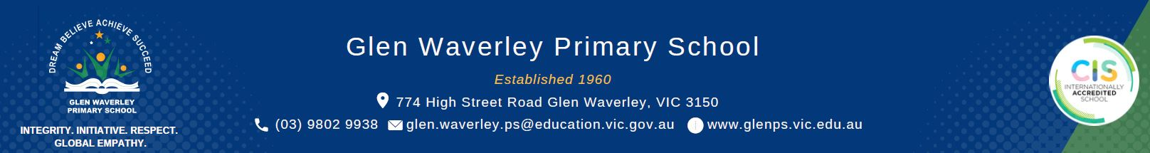

Preventing and Addressing Racism in Schools Policy

Racism is not tolerated at Glen Waverley Primary School
Glen Waverley Primary School is committed to fostering a welcoming, inclusive environment where racism is not tolerated. Racism harms students’ mental health, learning and sense of belonging. We celebrate the diversity of cultures, ethnicities and faiths of all our students. It is up to all of us at Glen Waverley Primary School to make our school a place that is free of racism and where everyone feels respected and can learn in a safe and inclusive environment.

What Glen Waverley Primary School is doing to prevent racism
Glen Waverley Primary School follows the Department of Education’s Preventing and Addressing Racism in Schools Policy. We are building a culturally safe school with inclusive learning for everyone by working with staff, students, families, carers and communities. We will:
- provide programs that teach about and celebrate diversity, inclusion and the impact of racism to build understanding and empathy
- use practices that support all students to thrive
- implement anti-racism efforts to prevent and address racism effectively
- make sure everyone feels safe, with clear and accessible pathways to report racism
- effectively teach transcultural views and acceptance as part of our core curriculum.

What to do if your child experiences or witnesses racism at school
If your child experiences or witnesses racism or religious discrimination at school, please let us know. You can tell your child’s teacher, the school Principal or Assistant Principals.

Report Racism hotline
If you don’t feel comfortable reporting racism to school, or you are not happy with the school’s response, you can report racism to:
- the Department of Education’s Report Racism hotline via email report.racism@education.vic.gov.au or phone 1800 722 476 (Monday to Friday, 9am to 5pm)
- Victorian Aboriginal Education Association Inc. (VAEAI) via email vaeai@vaeai.org.au or phone 03 9481 0800 (Monday to Friday, 9am to 5pm)
- Victorian Equal Opportunity and Human Rights Commission (VEOHRC) online, via email complaints@veohrc.vic.gov.au or phone 1300 292 153 (Monday to Friday 10am to 2pm).
For additional support following an incident of racism:
- First Nations students, staff or families can contact Victorian Aboriginal Education Association Inc. (VAEAI)
- Jewish students, staff or families can contact the Jewish Community Council of Victoria
- Muslim students, staff or families can contact the Islamic Council of Victoria

For more information about how to report racism to the school, and to get information in community languages, visit this website: Report racism or religious discrimination in schools.
If you need an interpreter to call the school, please use the details available at: Guide for Families: How to use an interpreter to contact your school.

How Glen Waverley Primary School will respond to racism
When you report a racist incident, Glen Waverley Primary School will:
- take your report seriously and act quickly
- give you ongoing support
- investigate and respond safely and appropriately
- keep you informed, while respecting privacy
- review the incident to help avoid it from happening again.

Policy Review and approval
Policy last reviewed | June 2025
Consultation | June 2025
Approved by | Principal
Next scheduled review date | May 2027

